**Installation and Setup Instructions:**

1. The project is very simple to install and deploy. Just download the project's zip by clicking on Clone or Download link.

2. Once the zip is downloaded, unzip it and navigate (cd) inside the NodeJsRestfulWebServiceMongoDB folder using terminal.

This folder contains all files and folders necessary for this project to run.

3. The package.json file contains all the necessary utilities that are needed for the project. Simply type 'npm install' inside the

NodeJsRestfulWebServiceMongoDB directory and it should download all the packages for you. In case you do not have Node.js

and/or npm installed on your machine, you can download it from here: https://www.npmjs.com/get-npm

4. Once the npm install runs fine, type in 'npm start' to start the server.

**Database Setup Instructions:**

1. Since I have used the cloud based of MongoDB i.e. Mongo DB Atlas, there is no need to install any database on your machine. The database connection link points to my cluster on the cloud which would have some sample data to start with.

2. The nodemon.json file stores all the environment variables used in my project. For security purposes, I am not including the database password in that file. I will provide you with that password separately and you can include that password on the MONGO_ATLAS_PW env variable in nodemon.js. Please make sure to include that before you do npm start.

3. Since MongoDB Atlas is cloud based cluster, the database table does not have a UI. I have created query which you can fire to see the existing list of users registered in the database.

However if you want to have a better overview of the db entries, you can download MongoDB Compass from here: <https://www.mongodb.com/products/compass> It is a free service, download it on your machine. After downloading, click on Connect Cluster and enter connection string and the details as given in the screenshot:

Connection String: mongodb+srv://root:<PASSWORD>@cluster0-xfcmc.mongodb.net/admin

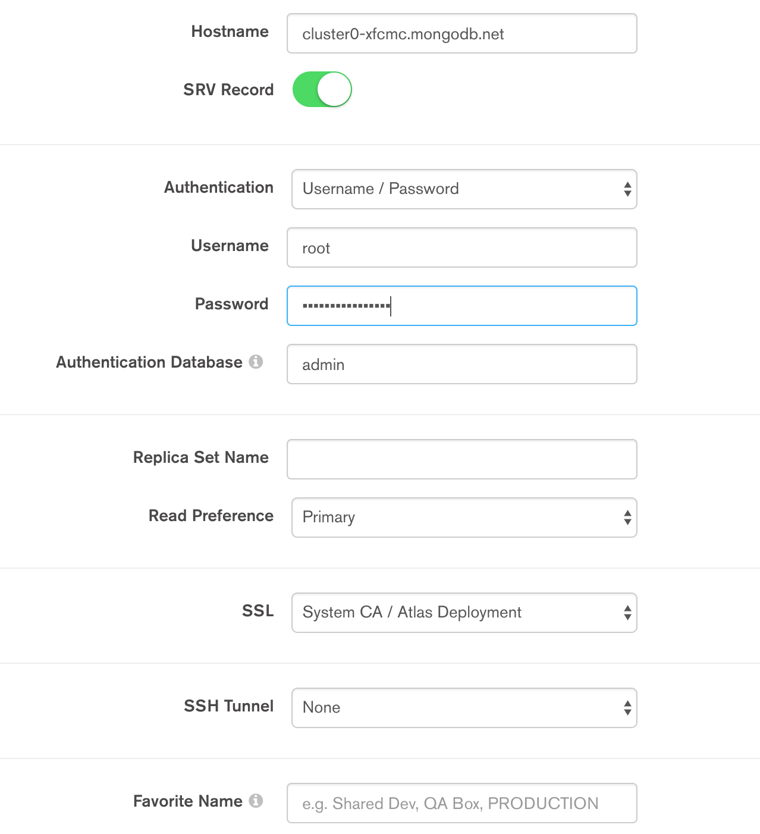

The password will be the same which I’ll provide. This should connect you to the cluster and you’d be able to see the ‘users’ table and its entries.